LED BLINKING
ALGORITHM

- Start
- Initialize microcontroller (Arduino/ESP32/STM32 etc.) in MBED/Proteus.
- Configure Pin:
Set LED pin (e.g., P0 or D13) as OUTPUT.
- Loop Process:
Turn LED ON (write HIGH to pin).
Wait for delay (e.g., 1000 ms).
Turn LED OFF (write LOW to pin).
Wait for delay (e.g., 1000 ms).
- Repeat steps continuously (infinite loop).
- End
INPUT
void setup() {
pinMode(2, OUTPUT);
}

void loop() {
digitalWrite(2,HIGH);
delay(1000);
digitalWrite(2,LOW);
delay(1000);
}

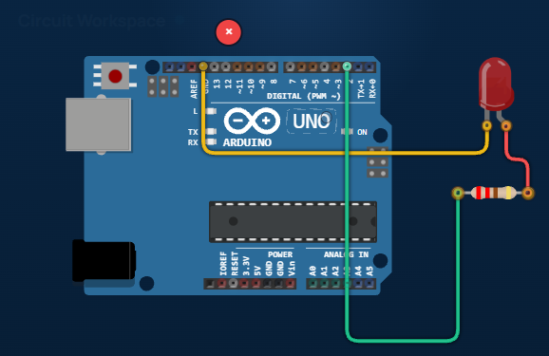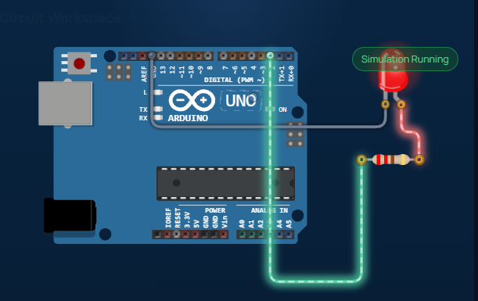
Traffic light control system

Algorithm

- Start
- Initialize microcontroller (Arduino UNO/ESP32).
- Configure Pins:
Red LED → OUTPUT
Yellow LED → OUTPUT
Green LED → OUTPUT
- Loop Process:
Turn Red ON → wait 5 seconds.
Turn Red OFF, Green ON → wait 5 seconds.
Turn Green OFF, Yellow ON → wait 2 seconds.
Turn Yellow OFF.
- Repeat steps continuously (infinite loop).
- End

INPUT
int red = 3;
int yellow = 2;
int green = 1;

void setup() {
pinMode(red, OUTPUT);
pinMode(yellow, OUTPUT);
pinMode(green, OUTPUT);
}

void loop() {
// Red ON
digitalWrite(red, HIGH);
digitalWrite(yellow, LOW);
digitalWrite(green, LOW);
delay(3000);

// Yellow ON
digitalWrite(red, LOW);
digitalWrite(yellow, HIGH);
digitalWrite(green, LOW);
delay(2000);

// Green ON
digitalWrite(red, LOW);
digitalWrite(yellow, LOW);
digitalWrite(green, HIGH);
delay(3000);
}

OUTPUT
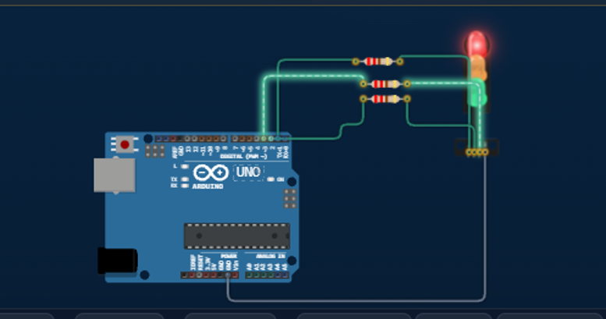

PIR MOTION ALERT SENSOR

ALGORITHM

- Start
- Initialize the PIR sensor, LED, and buzzer pins.
- Set the LED and buzzer as OUTPUT.
- Set the PIR sensor pin as INPUT.
- Read the PIR sensor output.
- Is motion detected?
  - Yes:
    - Turn LED ON.
    - Turn Buzzer ON.
    - Display/Print "Motion Detected!" (optional in Serial Monitor/LCD).
  - No:
    - Turn LED OFF.
    - Turn Buzzer OFF.
    - Display/Print "No Motion" (optional).
- Repeat Steps 5–6 continuously.
- End (program runs continuously in a loop).
Short Algorithm (for Record/Assignment)
- Start.
- Initialize PIR sensor, LED, and buzzer.
- Read PIR sensor output.
- If motion is detected:
  - LED = ON
  - Buzzer = ON
- Else:
  - LED = OFF
  - Buzzer = OFF
- Repeat the process continuously.
- End.

INPUT
const int pirPin = 2;
const int ledPin = 8;
const int buzzerPin = 9;

void setup() {
pinMode(pirPin, INPUT);
pinMode(ledPin, OUTPUT);
pinMode(buzzerPin, OUTPUT);

Serial.begin(9600);
}

void loop() {
int motion = digitalRead(pirPin);

if (motion == HIGH) {
digitalWrite(ledPin, HIGH);
digitalWrite(buzzerPin, HIGH);
Serial.println("Motion Detected!");
} else {
digitalWrite(ledPin, LOW);
digitalWrite(buzzerPin, LOW);
Serial.println("No Motion");
}

delay(100);
}

OUTPUT

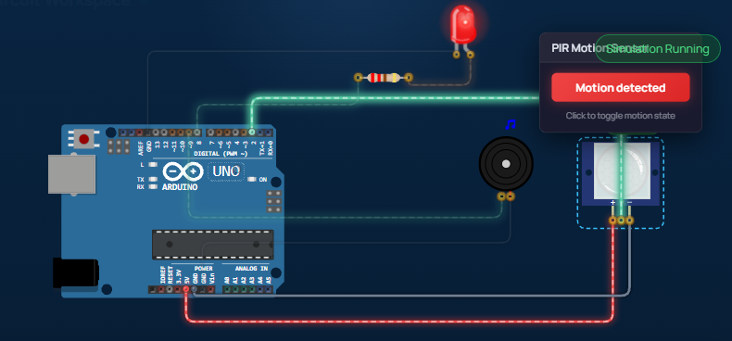

DISTANCE MEASUREMENT USING ULTRASONIC SENSOR

ALGORITHM
      - Initialize the TRIG and ECHO pins.
      - Set TRIG as OUTPUT.
      - Set ECHO as INPUT.
      - Send a 10 µs trigger pulse through the TRIG pin.
      - Measure the echo pulse duration from the ECHO pin.
      - Calculate the distance using:
Distance = (Duration × 0.0343) / 2
      - Display the distance in the Serial Monitor.
      - Repeat Steps 5–8 continuously.
      - End (the program runs continuously in a loop).
INPUT
const int trigPin = 9;
const int echoPin = 10;

long duration;
float distance;

void setup() {
pinMode(trigPin, OUTPUT);
pinMode(echoPin, INPUT);

Serial.begin(9600);
}

void loop() {
digitalWrite(trigPin, LOW);
delayMicroseconds(2);

digitalWrite(trigPin, HIGH);
delayMicroseconds(10);
digitalWrite(trigPin, LOW);

duration = pulseIn(echoPin, HIGH);

distance = duration * 0.0343 / 2;

Serial.print("Distance: ");
Serial.print(distance);
Serial.println(" cm");

delay(500);
}

OUTPUT

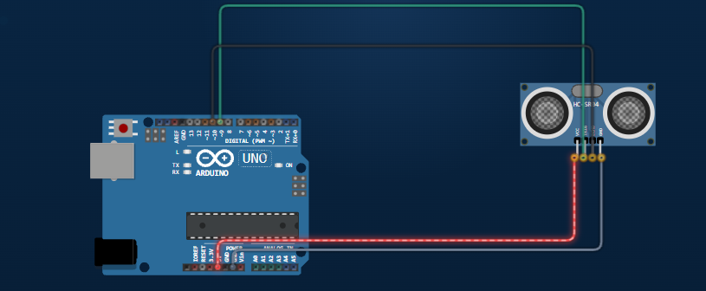
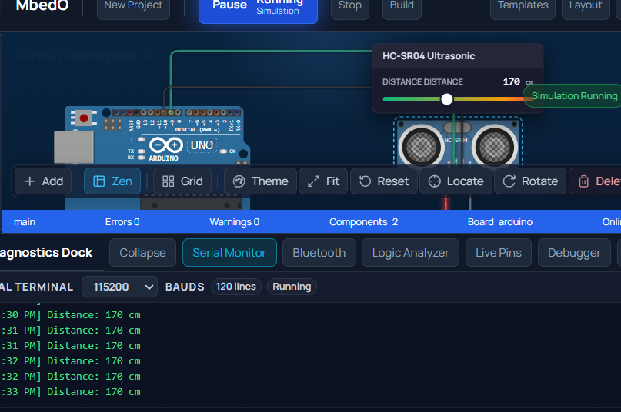

TEMPARATURE ALERT USING DHT22 SENSOR

ALGORITHM

- Start.
- Initialize the DHT22 sensor, LED, and buzzer.
- Read the temperature.
- If temperature > 30°C:
LED = ON
Buzzer = ON
Else:
LED = OFF
Buzzer = OFF
- Repeat continuously.
- End.
INPUT
#include <DHT.h>

#define DHTPIN 2
#define DHTTYPE DHT22

DHT dht(DHTPIN, DHTTYPE);

void setup() {
Serial.begin(9600);
dht.begin();
}

void loop() {
float temperature = dht.readTemperature();
float humidity = dht.readHumidity();

if (isnan(temperature) || isnan(humidity)) {
Serial.println("Failed to read from DHT22 sensor!");
delay(2000);
return;
}

Serial.print("Temperature: ");
Serial.print(temperature);
Serial.println(" °C");

Serial.print("Humidity: ");
Serial.print(humidity);
Serial.println(" %");

Serial.println("----------------------");

delay(2000);
}

OUTPUT
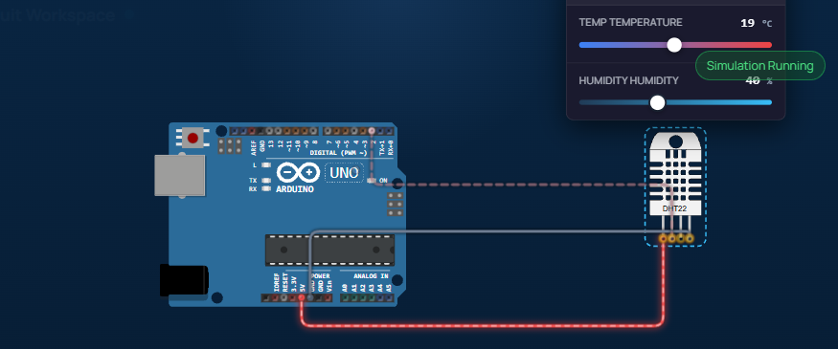
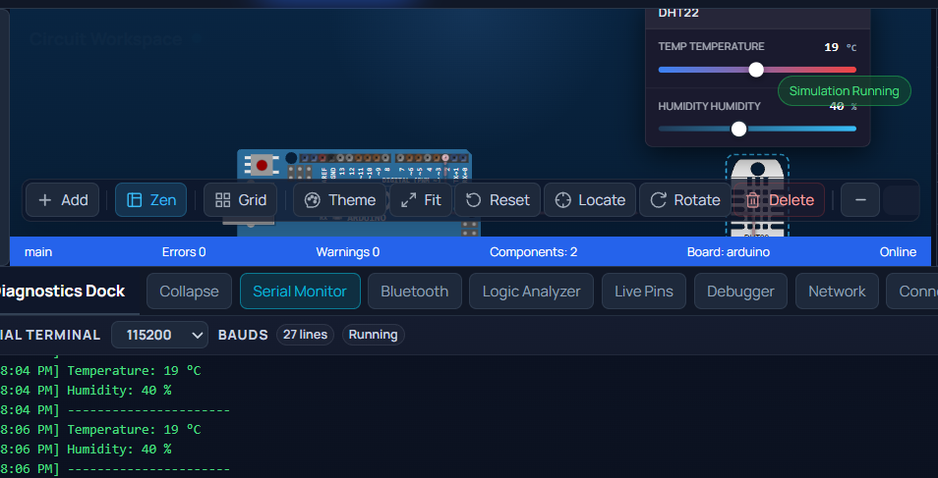

11.07.2026
Sanitizer using ultrasonic distance sensor and servo motor

Algorithm;
• Start
• Initialize the Ultrasonic Sensor (HC-SR04) and Servo Motor.
• Set the servo motor to its initial position (0°).
• Send a trigger pulse from the ultrasonic sensor.
• Receive the echo signal and calculate the distance.
• Check if the measured distance is less than or equal to 10 cm.
• If Yes:
- Rotate the servo motor to 90° to press the sanitizer pump.
- Wait for 1 second.
- Rotate the servo motor back to 0°.
• If No:
- Keep the servo motor at 0°.
• Repeat the distance measurement continuously.
• End (the program keeps runnin
g in a loop).

Input;

#include <Servo.h>

Servo sanitizer;

const int trigPin = 9;
const int echoPin = 10;
const int servoPin = 6;

long duration;
int distance;

void setup()
{
pinMode(trigPin, OUTPUT);
pinMode(echoPin, INPUT);

sanitizer.attach(servoPin);
sanitizer.write(0); // Initial position

Serial.begin(9600);
}

void loop()
{
// Trigger ultrasonic pulse
digitalWrite(trigPin, LOW);
delayMicroseconds(2);

digitalWrite(trigPin, HIGH);
delayMicroseconds(10);

digitalWrite(trigPin, LOW);

// Read echo
duration = pulseIn(echoPin, HIGH);

// Calculate distance
distance = duration * 0.034 / 2;

Serial.print("Distance: ");
Serial.print(distance);
Serial.println(" cm");

// Hand detected
if (distance > 0 && distance <= 10)
{
sanitizer.write(90); // Press sanitizer pump
delay(2000);

sanitizer.write(0); // Return to original position
delay(2000);
}
delay(100)
}
OUTPUT;
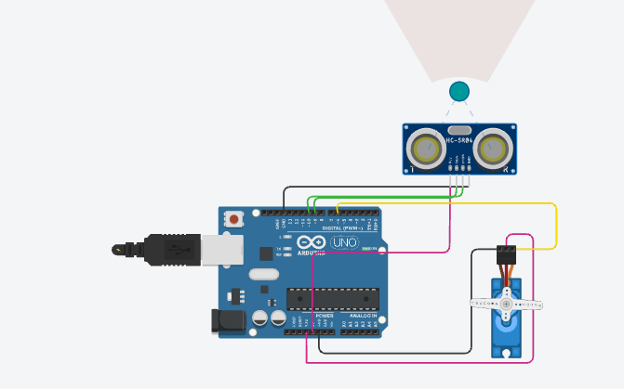


Pushbutton with buzzer operation
Algorithm;
- Start.
- Initialize the push button pin as INPUT_PULLUP.
- Initialize the buzzer pin as OUTPUT.
- Read the state of the push button.
- If the push button is pressed:
  - Turn ON the buzzer.
- Otherwise:
  - Turn OFF the buzzer.
- Repeat the process continuously.
- Stop.

INPUT;
const int buttonPin = 2;
const int buzzerPin = 8;

void setup()
{
pinMode(buttonPin, INPUT_PULLUP);
pinMode(buzzerPin, OUTPUT);
}

void loop()
{
int buttonState = digitalRead(buttonPin);

if (buttonState == LOW) // Button Pressed
{
digitalWrite(buzzerPin, HIGH);
}
else // Button Released
{
digitalWrite(buzzerPin, LOW);
}
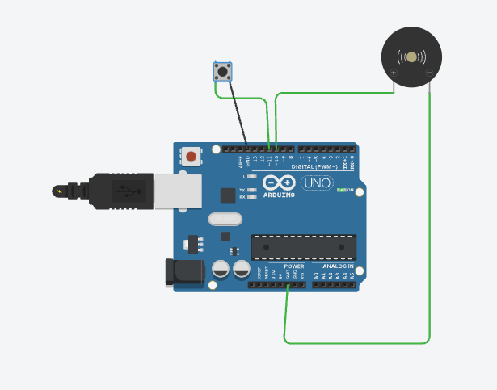

OUTPUT;

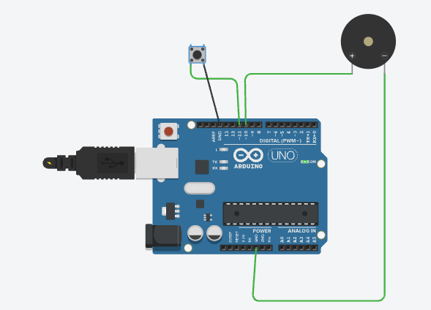

TWO WAY LED WITH TWO PUSH BUTTON
ALGORITHM;

• Start.
• Initialize Push Button 1 (D2) and Push Button 2 (D3) as INPUT_PULLUP.
• Initialize the LED pin (D8) as OUTPUT.
• Read the status of Push Button 1 and Push Button 2.
• If Push Button 1 is pressed:
- Turn the LED ON.
• Else if Push Button 2 is pressed:
- Turn the LED OFF.
• Continue checking the button status repeatedly.
• Stop.

INPUT;
const int button1 = 10;
const int button2 = 11;
const int ledPin = 7;

void setup() {
pinMode(button1, INPUT_PULLUP);
pinMode(button2, INPUT_PULLUP);
pinMode(ledPin, OUTPUT);

digitalWrite(ledPin, LOW);
}

void loop() {

if (digitalRead(button1) == LOW) {
digitalWrite(ledPin, HIGH); // Turn ON LED
}

if (digitalRead(button2) == LOW) {
digitalWrite(ledPin, LOW); // Turn OFF LED
}

}

OUTPUT;
